Automated Car Parking With Empty Slot Detection

System demonstrates a fully automated car parking system. For this purpose we use IR sensors along with motors, LCD display and microcontroller for controlling the
system working. Our system consists of an LCD display that is used to demonstrate as a parking gate entrance display.
The display displays empty slots to new car arriving at gate of parking area. If no parking space is available the system does not open the gate and displays parking full.
If slot is empty system allows car to enter the lot and displays empty slots where user can park. To detect vehicle slot occupancy the system uses IR sensors. Also system uses IR sensors to detect vehicles arriving at parking gates,
to open the gates automatically on vehicle arrival. The microcontroller is used to facilitate the working of the entire system.

Block Digarm:
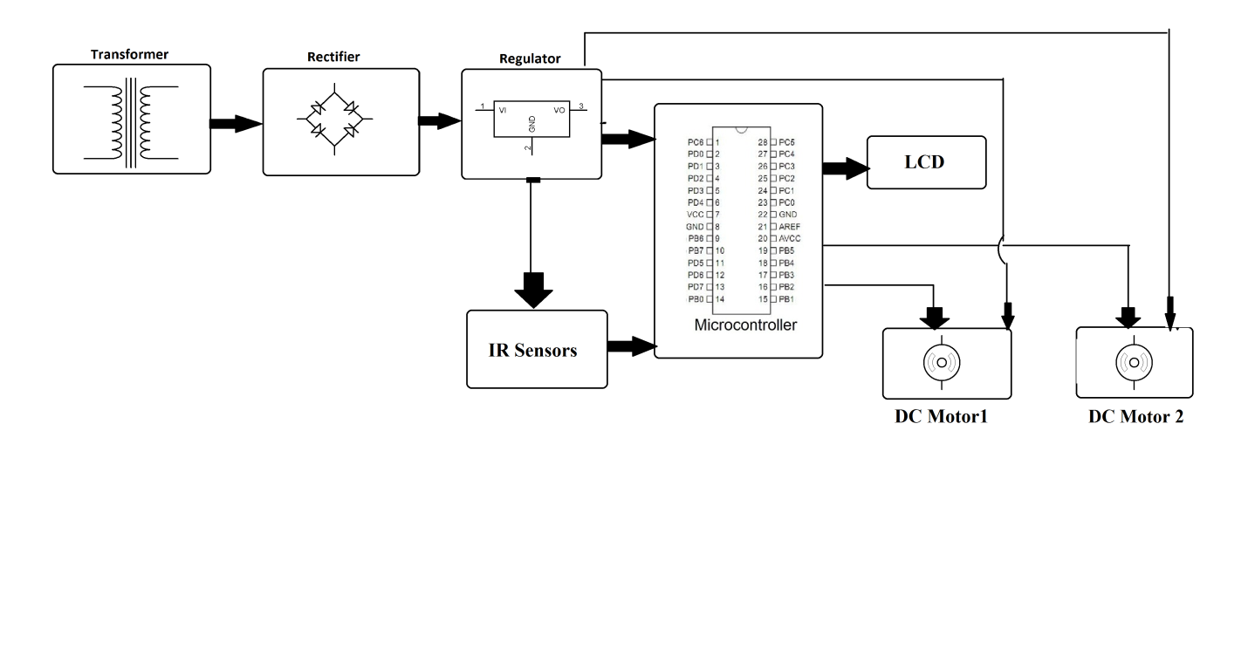
Hardware Specifications :
- Atmega 328 Microcontroller
- LCD Display
- IR Sensors
- Motors
- Transformer
- Resistors
- Capacitors
- Diodes
Software Specifications :
- Arduino Compiler
- MC Programming Language: C

Reference
- http://ieeexplore.ieee.org/xpl/articleDetails.jsp?arnumber=7399872&newsearch=true&queryText=parking%20sensor

- http://ieeexplore.ieee.org/xpl/articleDetails.jsp?arnumber=5557709&newsearch=true&queryText=parking%20sensor

